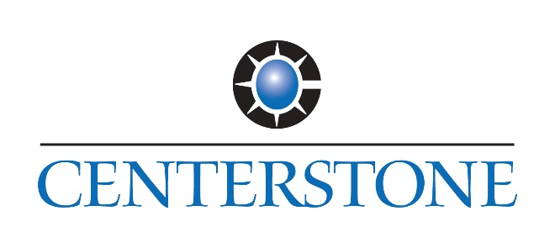
FOR IMMEDIATE RELEASE Contact: Dalus Ben Avi
Director of Marketing & Community Engagement
Centerstone
(618) 457-6703 ext. 7830
Dalus.benavi@centerstone.org

Date: 03/13/2019

Centerstone to launch Autism Services in March 2019
Ribbon-cutting and open house celebration to be held March 22

CARTERVILLE, Ill. (March 13, 2019) – Centerstone, a national leader in behavioral health care, joined by the Chambers of Commerce in Benton/West City, Carbondale, Carterville, Herrin, Marion, and West Frankfort, will host a ribbon-cutting celebration and open house on Friday, March 22, to commemorate the official launch of Centerstone Autism Services: Think! Learn! Explore! (CASTLE), an intensive, evidence-based therapy program for children between the ages of two- and five-years-old who have been diagnosed with Autism Spectrum Disorder (ASD).
The ribbon cutting will take place at 4:30 p.m. The open house will be held from 4-6 p.m. Everyone is invited to attend.
CASTLE will begin seeing clients on Monday, March 25.
CASTLE can help with a variety of challenges faced by children diagnosed with ASD including developing complex language and social skills (e.g., engaging in conversations with peers), completing daily living skills (e.g., toileting), learning age- and developmentally-appropriate academic skills (e.g., reading and writing), as well as decreasing challenging behaviors (e.g., aggression, non-compliance).
“At Centerstone, we understand that no two children are the same, so our services are individualized, and based on the identified strengths, needs, and priorities of clients and their families,” said Marty D. Price, Board Certified Behavior Analyst (BCBA) with Centerstone and the Behavior Analytic Program Manager.
Goals are determined based on a comprehensive assessment of the child’s current skills and deficits and may include skill domains such as development of age-appropriate academic and daily living skills, development of social skills and language, or behavior reduction.
“We believe in delivering care that changes people’s lives,” Price said.
Prior to beginning CASTLE therapy, a BCBA will conduct a comprehensive assessment of the child’s current skills and deficits. Language and behavioral assessments are used to identify potential causes for a child’s challenging behavior, as well as specific skills or general skill domains that should be targeted for improvement over the course of treatment.
Services will be provided in-clinic through a one-on-one format with a therapist or behavior analyst from the child’s treatment team. The BCBA assigned to the child’s case will create an individualized treatment plan for the client.
“At Centerstone, we consider parents and caregivers a vital component for client success. Our goal is to provide ongoing support to our families, in addition to teaching valuable new skills that they can use to implement components of their child’s programming within their everyday lives,” Price said.
Centerstone’s clinic-based service model includes ongoing support for parents and caregivers, as well as frequent parent training. Parents may receive a variety of trainings related to their child’s programming including but not limited to addressing behavioral concerns, implementation of the behavior plan, teaching activities of daily living, language and communication training, and providing learning opportunities in-home.
CASTLE is located at 402 East Plaza Drive, Suite #5, Carterville. Currently, CASTLE is accepting private pay and commercial insurance clients. For more information, call 855-608-3560.

About Centerstone
Centerstone is a not-for-profit health care organization dedicated to delivering care that changes people’s lives. We provide mental health and substance abuse treatment, education and support to communities in Florida, Illinois, Indiana, Kentucky, and Tennessee and additionally offer individuals with intellectual and developmental disabilities life skills development, employment and housing services. Nationally, we have specialized programs for service members, veterans and their loved ones, and develop employee assistance programs for businesses of all sizes. Our research institute improves behavioral healthcare through research and technology, and our foundation secures philanthropic resources to support our work. For more information, visit www.centerstone.org.

Art included:

ABA flier

###

